\*\*\*how to create github account and push all the programs c/python in that

1.Create github account

<https://github.com/>

2.Sign in to account

3. install git for windows

So download

<https://github.com/git-for-windows/git/releases/download/v2.45.2.windows.1/Git-2.45.2-64-bit.exe>

after downloading the git file open in and press on next till to install

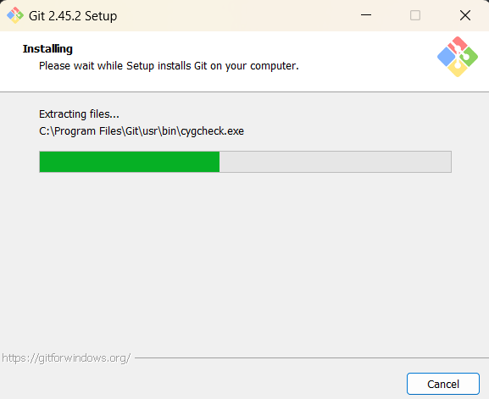

Open git hub:

Then create new reporatory by clicking + icon on top right

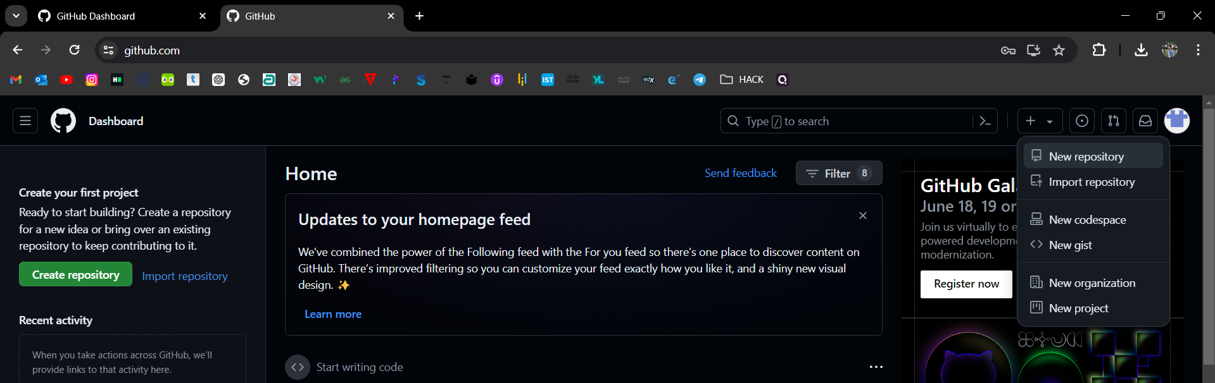

Enter repository name

Description(optional)

Public/private – visibility

Then click on create

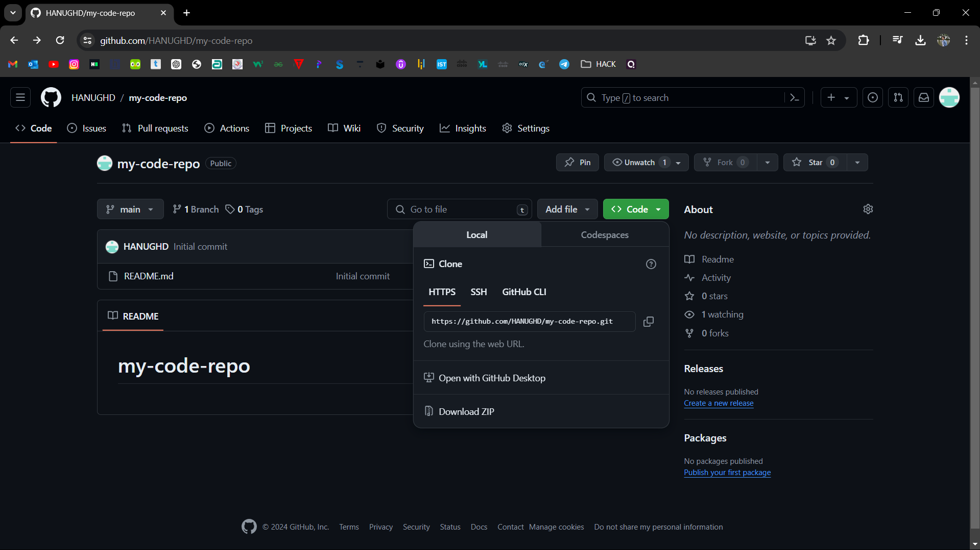

Now open vs code then open git basj in terminal

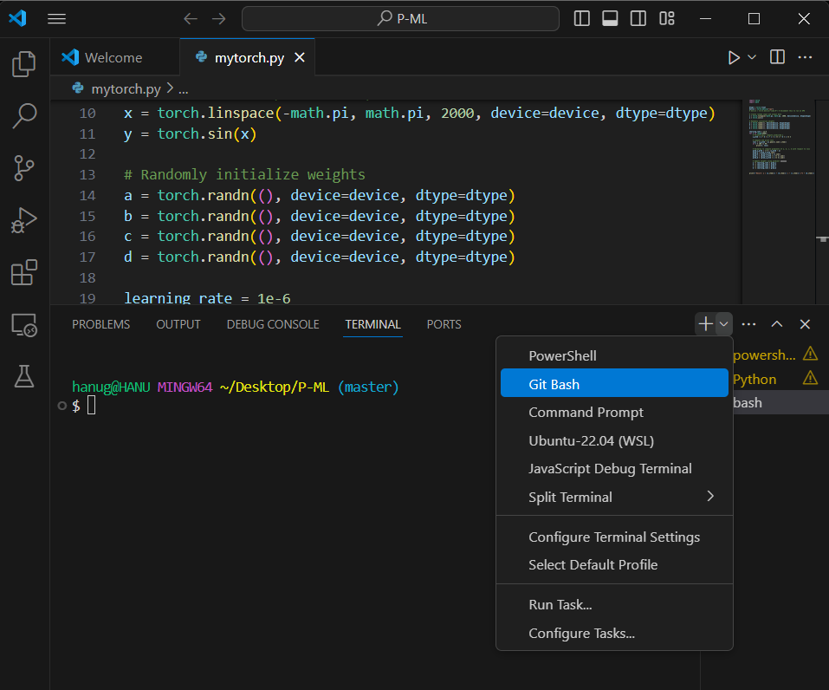

Type cmd:

1.git init

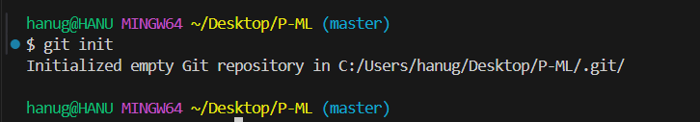

2. cmd: git remote add origin “url link”

Git remote add origin <https://github.com/HANUGHD/my-code-repo.git>

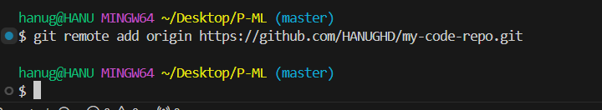

3. cmd: git add .

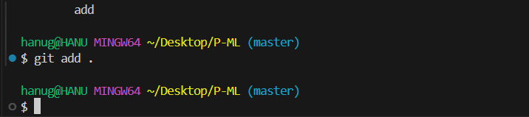

4. cmd : git commit -m “Initial commit”

Load all files in the folder

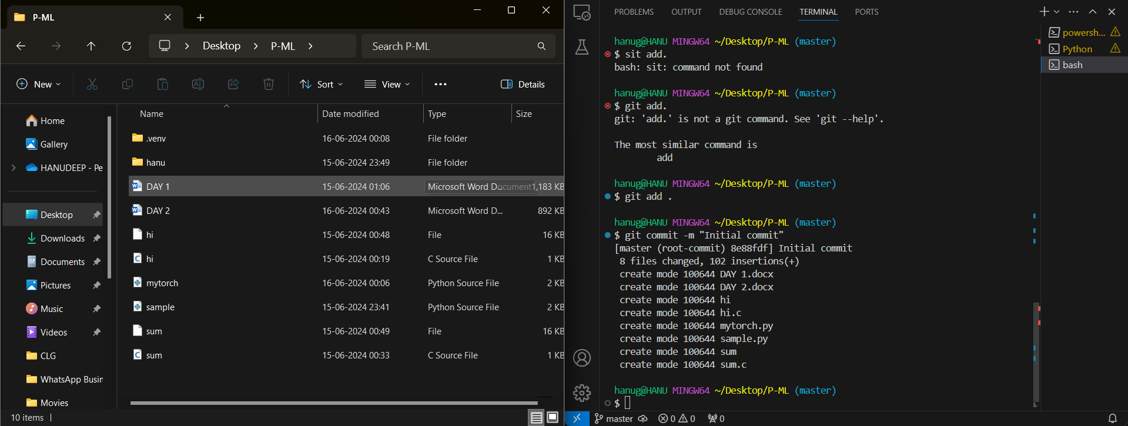

At last enter cmd

5.cmd: git push -u origin master

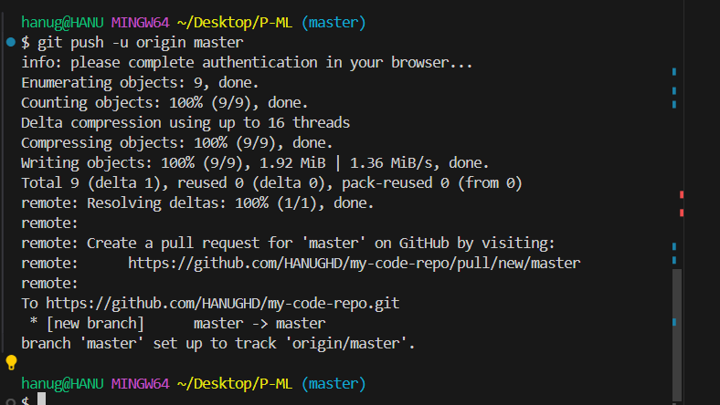

After the go to your git hub page and reload it

We can see all codes in the file will be uploaded to git

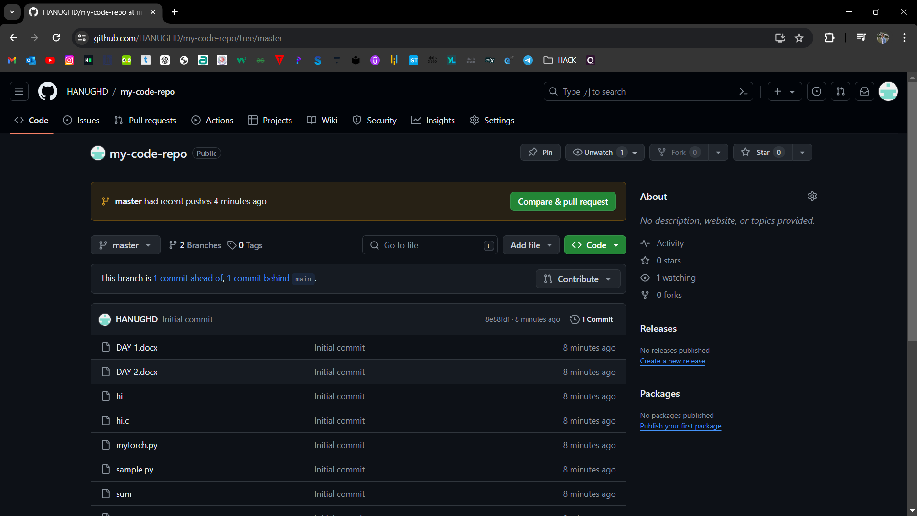

And also we can check through the link too

<https://github.com/HANUGHD/my-code-repo.git>

----------------------------------------------------------------------------------------------------------------------------------------------------------